**P530/2**

**BIOLOGY**

**(Theory)**

**Paper 2**

**July/Aug. 2016**

**2 ½ hours**



**MUKONO EXAMINATION COUNCIL**

**Uganda Advanced Certificate of Education**

**BIOLOGY**

**(THEORY)**

Paper 2

**2 hours 30 minutes**

**INSTRUCTIONS TO CANDIDATES**

* *This paper consists of* ***SIX*** *questions.*
* *Answer questions* ***ONE*** *in Section a plus* ***three*** *others from section* ***B****.*
* *Candidates are advised to read the questions carefully, organise their answers and present them precisely and logically, illustrating with well labelled diagrams.*

**SECTION A: (40 Marks)**

1. The figure below shows the changes in temperature and dissolved oxygen levels of a deep fresh water lake in water and during summer season.

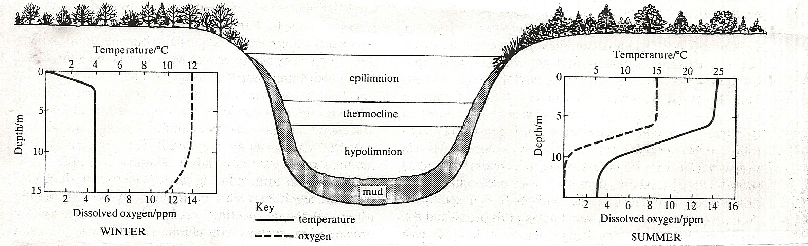

1. Compare the changes in temperature and dissolved oxygen in the lake between winter and summer. ***(6 marks)***
2. Explain the variation in dissolved oxygen during;
3. Winter ***(7 marks)***
4. Summer ***(10 marks)***
5. Outline the probable source of;
6. dissolved oxygen in the lake. ***(2 marks)***
7. temperature variation in the lake. ***(3 marks)***
8. How does increase in temperature affect the chemical composition of the lake?

***(5 marks)***

1. What would happen if untreated sewage and excess fertilizers were damped in such a lake? ***(7 marks)***

**SECTION B: (60 marks)**

1. a) Give an outline of how DNA and mRNA are related. ***(5 marks)***

b) What is the significance of the genetic code in the life of an organism? ***(8 marks)***

c) Explain how polypeptide chains are folded after protein synthesis. ***(7 marks)***

1. a) Outline the respiratory pathway using lipids as a substrate. ***(6marks)***

b) Discuss briefly the factors that affect the basal metabolic rate in man.***(14marks)***

1. a) Compare the mammalian and insect compound eye. ***(12marks)***

b) How is the structure of the mammalian eye modified to increases efficiency of sensory cells in the retina? ***(8 marks)***

1. a) Compare the changes that occur in the reproductive organs leading to formation

of gametes in man. ***(10marks)***

b) Outline the differences in blood circulation between the foetus and adult

mammal. ***(10marks)***

1. a) Discuss the ecological significance of light intensity as a limiting factor in photosynthesis. ***(11marks)***

b) How does enzyme-substrate interaction contribute to the net-productivity in plants? ***(8 marks)***

***End -***